Ideation Phase
Define the Problem Statements

Date | 20 February 2026
Team ID | LTVIP2026TMIDS77212
Project Name | FreelanceFinder: Discovering Opportunities, Unlocking Potential
Maximum Marks | 2 Marks
Customer Problem Statement Template:
In today’s freelancing industry, connecting clients with reliable freelancers can be challenging. Traditional methods often lack structured communication, transparent workflows, and proper project tracking. This results in misunderstandings, delayed deliveries, and reduced trust between users. Freelancers struggle to find genuine opportunities, while clients face difficulty identifying skilled professionals. Many systems do not provide secure and centralized collaboration. SB Works aims to solve these issues by offering a streamlined digital platform for efficient project management and secure freelance collaboration.
Problem Statement -1:
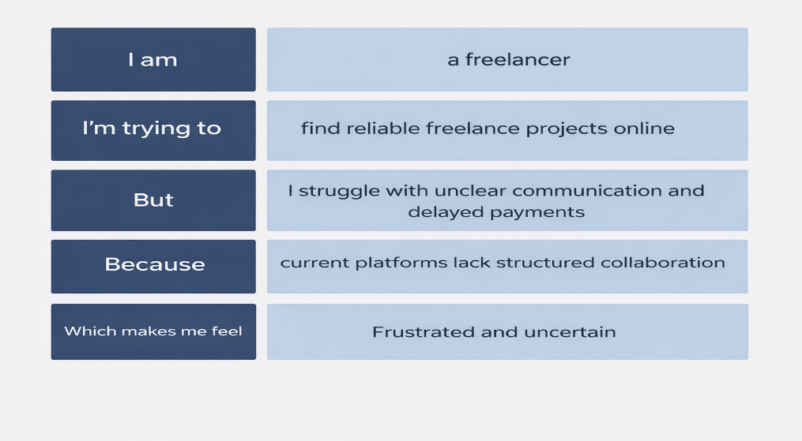
Problem Statement -2:
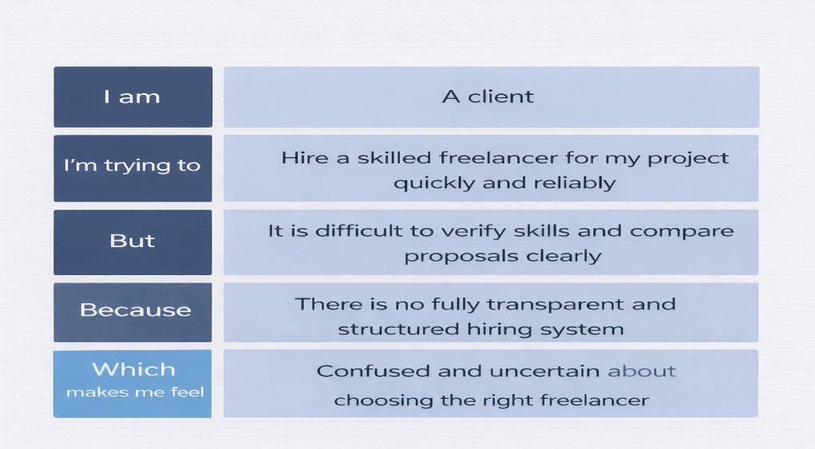

Problem Statement (PS) | I am | I’m trying to | But | Because | Which makes me feel
PS-1 | A freelancer | Find genuine projects and manage my work efficiently | Project details are unclear and communication is scattered | There is no centralized and transparent collaboration system | Frustrated and uncertain
PS-2 | A client | Hire a skilled freelancer quickly and reliably | It is difficult to verify skills and compare proposals clearly | There is no fully transparent and structured hiring system | Confused and uncertain

